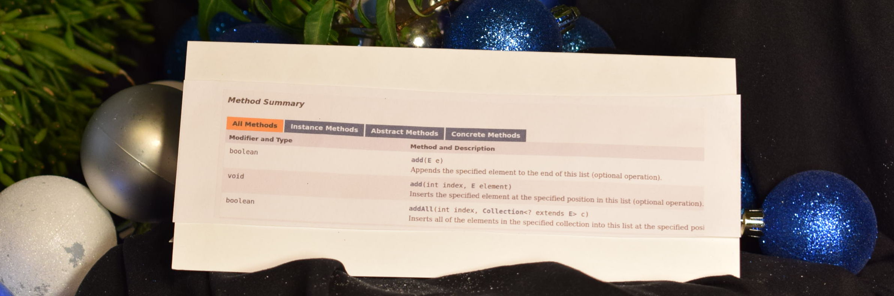 |  |  |  |  | Method diagrams  When you adapted quiz program is completed, transfer the lines of code that include calls to library methods on library classes. In your example, annotate the input parameters with underlines and the return values in a box:  Library class & method call 1:  The Heart of the Matter: Practicing skills at mastery  Demonstrate that you know how to read the Java API documentation and use one of the methods on one of its classes.  1. Navigate to the java.lang.StringBuilder class  2. Locate the method with the signature:  StringBuilder append(String str)  3. USING ONLY THIS MODULE’S RESOURCES, please write 5-8 lines of code below (or typed and printed) that make a StringBuilder instance and call the append() method. Note that after you call append, you can call the toString() method on your StringBuilder object to get the String value inside the StringBuilder back out to System.out.println().
API1 | Name | Section Day(s) | Section start time
Component
Chunk 4: Storage, Module 2: The Java API
Module Overview:

We can harness the complex power of computers by learning how to use code that others folks have written and shared with us to use. This code is collected in a set of packages called the Java Standard Library. We access the features of the standard library through its interface -- the Application Programming Interface (The Java API)
Learning objectives
As you review each objective, pause to fill in any gaps in understanding you have
Mastery? | Objective
 | Digest and diagram the Java library's Application Programming Interface documentation so you can explain what a method does and how one might use it in a program
 | Use a method on a library class to accomplish a useful task in a program, such as the String.subString(int startingIndex) method
 | Adapt an object-oriented quiz program which uses the Java Library's LinkedList class and its various methods to create a customized application

Hamburger Contents: Check ‘em off!
Assemble all of these items and slide them into this document folded hamburger style. Place on the right pocket of your folder, please.
Got it? | Description
 | Printed version of your quiz classes
 | Notes, sketches, & other project-related documents
 | This hamburger, thoughtfully completed

