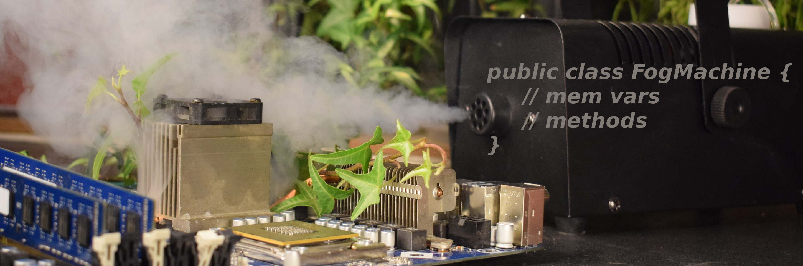 |  |  |  |  | Method diagrams  Complete method diagrams for two of your own methods. Include the method name, input types, the name of the calling method, and the return (output) type. See the project guide for examples.  Method 1 Diagram:  Method 2 Diagram:  The Heart of the Matter  You are pitching your object model to a group of developers who have volunteered to help you continue building your object into a full-fledged application. Respond to their question: “How is using Java’s object model an appropriate choice for for representing the material object you chose?” (Write below, or feel free to type, of course.)
Proj | Name | Section Day(s) | Section start time
Component
The Object Project!
Module Overview:

Put your skills to good use by choosing an object that has some interesting behavior that you'd like to model (guitars, calculators, etc.), plan out your object, and then transform that plan into Java code!
Learning objectives
As you review each objective, pause to fill in any gaps in understanding you have
Mastery? | Objective
 | Create a class diagram that represents the state (member variables) and functionality (methods) of a single physical object
 | Translate a class diagram into a Java class (or set of classes) that models the behavior of the planned object through command-line interaction and contains no main() method
 | Create a class with a main() method which creates an instance of the modeled object and demonstrates all of its functionality.fixed

Hamburger Contents: Check ‘em off!
Assemble all of these items and slide them into this document folded hamburger style. Place on the right pocket of your folder, please.
Got it? | Description
 | First draft of class diagram
 | Updated and tidied class diagram of final application
 | Notes, sketches, & other project-related documents
 | This hamburger, thoughtfully completed

