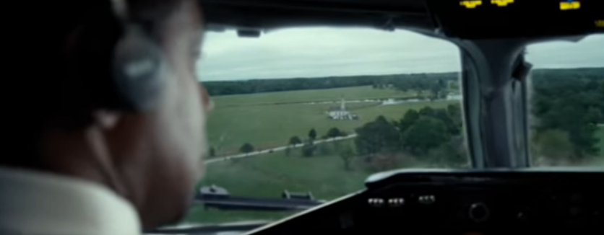 |  |  |  |  |  | Method call analysis  Java programs basically consist of methods on one object calling methods on another object to get meaningful work done. Analyze a few of these method call relationships by completing the diagrams below:  Simple Method relationship 1  Method relationship 2  Method relationship 1
  Class: | CALLS  ------> | Class:
  Method name: | CALLS  ------> | Method name:
  Arguments to method:  no arguments | CALLS  ------> | Parameter variables:  takes no parameters
  Return value capture var  n/a | RETURNS  <------ | Return variable  No return value
  Class: | CALLS  ------> | Class:
  Method name: | CALLS  ------> | Method name:
  Arguments to method: | CALLS  ------> | Parameter variables:
  Return value capture var | RETURNS  <------ | Return variable
  Class: | CALLS  ------> | Class:
  Method name: | CALLS  ------> | Method name:
  Arguments to method: | CALLS  ------> | Parameter variables:
  Return value capture var | RETURNS  <------ | Return variable
OOP3 | Name |  | Section Day(s) | Section start time
omponent  Java Objects |  | Module  Mission Control
Learning objectives
As you review each objective, pause to fill in any gaps in understanding you have
Peer Signoff | Objective | Your initials
 | Read (i.e. digest) Java code written using an object-oriented approach
 | Analyze program output to determine the likely nature of a bug. Locate and squash the bug.
 | Write an additional class for missionControl which calls methods on existing objects.

Hamburger Contents: Check ‘em off!
Assemble all of these items and slide them into this document folded hamburger style. Place on the right pocket of your folder, please.
Got it? | Description
 | On BACK: Class diagrams (mem vars & methods) for each class in missionControl, including your new class.
 | Working code for new code in a mission control class
 | Commented code—before you print, add comments (1 line is all) in front of the key lines of code in your Classes.
 | Print and HIGHLIGHT the working and commented code. Remember to use the Object-Oriented color guide.
 | This hamburger, thoughtfully completed

